附件1

揭阳市部分乡镇级及以下饮用水水源保护区划定与调整方案

| **序号** | **调整前保护区名称** | **调整前保护区范围** | | | | **调整后保护区名称** | **水质目标** | **调整后保护区范围** | | | | **备注** |
| --- | --- | --- | --- | --- | --- | --- | --- | --- | --- | --- | --- | --- |
| **保护区级别** | **水域** | **陆域** | **面积（km2）** | **保护区级别** | **水域** | **陆域** | **面积（km2）** |
| 1 | 白塔至月城河段饮用水水源保护区 | 一级 | 白塔宝联至霖磐河段。 | 两岸向陆纵深50米集雨面积内。 | 1.733 | 白塔至月城河段饮用水水源保护区 | II类 | 一级 | 三洲拦河闸上游边界起上溯3117m的水域范围（即榕江南河白塔水厂取水口上游1000m至三洲拦河闸上游边界的水域范围）。 | 相应一级保护区水域沿岸向陆纵深50米的陆域范围，但不超过榕江南河两侧防洪堤围迎水坡堤肩线或滨河道路迎河侧路肩线的陆域范围。 | 1.741 | 调整 |
| 二级 | 除一级保护区外的其他区域。 | 两岸向陆纵深50米集雨面积内。 | 3.658 | 二级 | 榕江南河一级保护区上游边界起上溯2000m，白塔新溪汇入榕江南河一级保护区边界起上溯2000m河段的水域范围。 | 榕江南河相应一级及二级保护区水域沿岸向陆纵深至两侧防洪堤围迎水坡堤肩线或滨河道路迎河侧路肩线，除一级保护区外的陆域范围。白塔新溪相应二级保护区水域沿岸向陆纵深50米，但不超过两侧堤围迎水坡堤肩线的陆域范围。 | 1.712 |
| 2 | 钱坑饮用水水源一级保护区 | 一级 | 河婆镇出水口至钱坑拦河坝水域。 | 相应一级保护区水域两岸河堤外坡脚向陆纵深50米的陆域。 | 6.427 | 钱坑饮用水水源保护区 | II类 | 一级 | 象山水电站下游0.70km处至乌石拦河闸上游1.39km处，除甬莞高速（G1523）、省道S239中心线穿越位置上下游各100m的水域范围。 | 相应一级保护区水域向陆纵深50米的陆域范围。 | 6.293 | 待S239按要求完善设施并向市政府报备相关材料后，其穿越钱坑饮用水水源保护区河段的保护区调整方案方可生效。 |
| 二级 | —— | —— | 0 | 二级 | 甬莞高速（G1523）、省道S239中心线穿越位置上下游各100m的水域范围。 | 相应二级保护区水域向陆纵深50米的陆域范围。 | 0.134 |
| 3 | 顶溪水库饮用水水源一级保护区 | 一级 | 顶溪水库全部水域。水质保护目标为Ⅱ类。 | 顶溪水库35.9米正常水位线向陆纵深1000米。 | 15.907 | 顶溪水库饮用水水源保护区 | II类 | 一级 | 顶溪水库正常水位线（20.85m）以下全部水域范围。 | 顶溪水库相应一级保护区水域边界沿岸向陆纵深200米，不超过流域分水岭的陆域。 | 4.959 | 调整 |
| 二级 | —— | —— |  | 二级 | 顶溪水库集雨区内除一级保护区以外的全部水域范围。 | 顶溪水库周边分水岭内的汇水区域（一级保护区除外）。 | 10.286 |
| 4 | 溪东河饮用水水源一级保护区 | 一级 | 溪东河溪东水厂取水点上游2000米至“鹰打兔”河段水域，水质保护目标Ⅱ类。 | 相应一级保护区水域两岸河堤外坡脚向陆纵深50米的陆域。 | 0.245 | —— | II类 | 一级 | —— | —— |  | 待惠来县中心城区水厂建成并实际向神泉镇供水，神泉镇水厂在溪东河上的取水口拆除后，取消该保护区。 |
| 5 | 排坑水库饮用水水源一级保护区 | 一级 | 排坑水库全部水域，水质保护目标为Ⅱ类。 | 水库1平方公里集水面积。 | 0.971 | —— | II类 | 一级 | —— | —— |  | 取消 |
| 6 | 古目实水库饮用水水源一级保护区 | 一级 | 古目实水库全部水域，水质保护目标为Ⅱ类。 | 水库全部集水面积。 | 0.430 | —— | II类 | 一级 | —— | —— |  | 取消 |
| 7 | —— | —— | —— | —— | 0 | 船埔镇青潭村养坑仔山溪水饮用水水源保护区 | II类 | 一级 | 养坑仔山溪水引水陂上游集雨区内的水域范围。 | 养坑仔山溪水引水陂上游集雨区内的陆域范围。 | 0.641 | 新划定 |

附件2

### 揭阳市部分乡镇级及以下饮用水水源保护区

### 划定与调整方案坐标

白塔至月城河段饮用水水源保护区坐标

| 序号 | 纬度 | 经度 |  | 序号 | 纬度 | 经度 |
| --- | --- | --- | --- | --- | --- | --- |
| A1 | E116°11'58.942" | N23°31'39.233" |  | B4 | E116°10'36.147" | N23°32'10.960" |
| A2 | E116°12'4.651" | N23°31'41.203" | B5 | E116°10'38.634" | N23°32'12.436" |
| A3 | E116°12'12.057" | N23°31'28.478" | B6 | E116°11'0.088" | N23°31'51.016" |
| A4 | E116°12'2.082" | N23°31'23.187" | B7 | E116°11'11.942" | N23°31'29.803" |
| A5 | E116°11'49.006" | N23°31'15.818" | B8 | E116°11'48.114" | N23°31'39.689" |
| A6 | E116°11'37.877" | N23°31'11.912" | B9 | E116°12'2.369" | N23°31'45.346" |
| A7 | E116°11'22.253" | N23°31'9.032" | B10 | E116°12'12.808" | N23°31'27.137" |
| A8 | E116°11'11.239" | N23°31'1.147" | B11 | E116°11'47.982" | N23°31'13.373" |
| A9 | E116°11'12.165" | N23°30'55.061" | B12 | E116°11'24.032" | N23°31'4.373" |
| A10 | E116°10'52.769" | N23°30'49.462" | B13 | E116°11'13.100" | N23°30'49.542" |
| A11 | E116°10'29.982" | N23°30'48.730" | B14 | E116°10'54.178" | N23°30'44.954" |
| A13 | E116°10'24.593" | N23°31'3.149" | B15 | E116°10'26.922" | N23°30'43.124" |
| A14 | E116°10'44.762" | N23°31'14.055" | B16 | E116°10'5.289" | N23°30'30.798" |
| A15 | E116°10'59.469" | N23°31'15.223" | B17 | E116°9'58.287" | N23°30'20.234" |
| A16 | E116°11'7.958" | N23°31'14.275" | B18 | E116°10'3.308" | N23°30'13.691" |
| A17 | E116°11'22.009" | N23°31'22.850" | B19 | E116°9'56.007" | N23°30'5.161" |
| A18 | E116°11'37.661" | N23°31'27.996" | B20 | E116°9'33.396" | N23°30'13.993" |
| A19 | E116°11'47.359" | N23°31'33.781" | B21 | E116°9'43.649" | N23°30'36.490" |
| A20 | E116°11'53.582" | N23°31'41.495" | B22 | E116°9'59.499" | N23°30'51.797" |
| B1 | E116°11'10.780" | N23°31'22.166" | B23 | E116°10'14.846" | N23°30'58.264" |
| B2 | E116°11'10.009" | N23°31'29.140" | B24 | E116°10'33.415" | N23°31'8.579" |
| B3 | E116°10'56.265" | N23°31'49.668" |  |  |  |

钱坑饮用水水源保护区坐标

| 序号 | 纬度 | 经度 |  | 序号 | 纬度 | 经度 |
| --- | --- | --- | --- | --- | --- | --- |
| A1 | E116°0'2.758" | N23°23'9.548" |  | A21 | E115°53'4.000" | N23°25'17.765" |
| A2 | E115°59'58.340" | N23°23'1.492" | A22 | E115°53'33.250" | N23°25'17.323" |
| A3 | E115°58'41.377" | N23°23'28.331" | A23 | E115°54'7.420" | N23°24'48.553" |
| A4 | E115°58'36.567" | N23°24'53.193" | A24 | E115°54'33.946" | N23°24'55.601" |
| A5 | E115°58'55.101" | N23°25'20.717" | A25 | E115°55'3.441" | N23°25'49.303" |
| A6 | E115°58'47.547" | N23°25'45.022" | A26 | E115°55'22.473" | N23°25'26.854" |
| A7 | E115°56'39.752" | N23°26'38.517" | A27 | E115°56'18.517" | N23°26'14.909" |
| A8 | E115°56'26.423" | N23°26'7.269" | A28 | E115°56'38.969" | N23°26'45.690" |
| A9 | E115°55'22.699" | N23°25'20.635" | A29 | E115°58'53.679" | N23°25'52.427" |
| A10 | E115°55'4.433" | N23°25'41.675" | A30 | E115°59'3.890" | N23°25'20.112" |
| A11 | E115°54'42.376" | N23°24'52.085" | A31 | E115°58'45.664" | N23°24'54.053" |
| A12 | E115°54'6.325" | N23°24'40.011" | A32 | E115°58'50.851" | N23°23'31.842" |
| A13 | E115°53'31.872" | N23°25'9.360" | B1 | E115°56'52.789" | N23°26'13.602" |
| A14 | E115°53'8.549" | N23°25'9.967" | B2 | E115°56'55.790" | N23°26'7.171" |
| A15 | E115°52'49.192" | N23°24'42.347" | B3 | E115°57'4.551" | N23°26'15.328" |
| A16 | E115°51'24.247" | N23°24'52.336" | B4 | E115°57'1.162" | N23°26'21.245" |
| A17 | E115°50'47.822" | N23°24'56.323" | B5 | E115°58'52.205" | N23°24'9.162" |
| A18 | E115°50'52.185" | N23°25'0.274" | B6 | E115°59'2.992" | N23°24'5.306" |
| A19 | E115°51'24.900" | N23°24'58.959" | B7 | E115°59'0.307" | N23°23'59.294" |
| A20 | E115°52'45.537" | N23°24'46.402" | B8 | E115°58'50.384" | N23°24'2.825" |

顶溪水库饮用水水源保护区坐标

| 序号 | 纬度 | 经度 |  | 序号 | 纬度 | 经度 |
| --- | --- | --- | --- | --- | --- | --- |
| A1 | E116°29'57.604" | N23°4'56.570" |  | A17 | E116°28'50.052" | N23°5'5.693" |
| A2 | E116°29'52.337" | N23°4'50.258" | A18 | E116°29'13.711" | N23°5'5.444" |
| A3 | E116°29'49.988" | N23°4'23.481" | A19 | E116°29'30.352" | N23°4'59.504" |
| A4 | E116°29'32.906" | N23°4'14.146" | A20 | E116°29'51.336" | N23°5'1.546" |
| A5 | E116°29'17.768" | N23°4'13.892" | B1 | E116°27'14.899" | N23°4'26.577" |
| A6 | E116°29'2.662" | N23°4'29.250" | B2 | E116°26'50.814" | N23°4'55.380" |
| A7 | E116°28'37.786" | N23°4'21.283" | B3 | E116°26'34.250" | N23°5'24.247" |
| A8 | E116°28'18.795" | N23°4'16.940" | B4 | E116°27'6.356" | N23°5'39.347" |
| A9 | E116°28'5.072" | N23°4'23.736" | B5 | E116°27'32.787" | N23°5'49.062" |
| A10 | E116°27'49.957" | N23°4'25.615" | B6 | E116°27'56.476" | N23°6'5.533" |
| A11 | E116°27'40.375" | N23°4'32.202" | B7 | E116°28'22.167" | N23°6'6.357" |
| A12 | E116°27'39.332" | N23°4'50.079" | B8 | E116°28'49.348" | N23°6'20.336" |
| A13 | E116°27'54.949" | N23°5'0.636" | B9 | E116°29'24.647" | N23°6'19.541" |
| A14 | E116°28'14.470" | N23°4'57.303" | B10 | E116°29'39.155" | N23°5'52.555" |
| A15 | E116°28'25.740" | N23°5'9.541" | B11 | E116°29'37.237" | N23°5'21.972" |
| A16 | E116°28'37.451" | N23°5'18.418" | B12 | E116°30'1.532" | N23°5'4.801" |

船埔镇青潭村养坑仔山溪水饮用水水源保护区坐标

| 序号 | 纬度 | 经度 |  | 序号 | 纬度 | 经度 |
| --- | --- | --- | --- | --- | --- | --- |
| A1 | E115°51'27.344" | N23°16'56.476" |  | A9 | E115°51'14.929" | N23°16'21.594" |
| A2 | E115°51'36.078" | N23°16'51.326" | A10 | E115°51'12.800" | N23°16'25.920" |
| A3 | E115°51'34.965" | N23°16'46.794" | A11 | E115°51'15.314" | N23°16'31.111" |
| A4 | E115°51'37.808" | N23°16'39.694" | A12 | E115°51'9.628" | N23°16'35.052" |
| A5 | E115°51'38.083" | N23°16'33.473" | A13 | E115°51'8.159" | N23°16'39.117" |
| A6 | E115°51'34.361" | N23°16'31.207" | A14 | E115°51'9.834" | N23°16'44.432" |
| A7 | E115°51'28.044" | N23°16'22.995" | A15 | E115°51'17.085" | N23°16'50.378" |
| A8 | E115°51'23.306" | N23°16'20.688" | A16 | E115°51'20.271" | N23°16'56.846" |

附件3

揭阳市部分乡镇级及以下饮用水水源保护区划定与调整方案范围图件

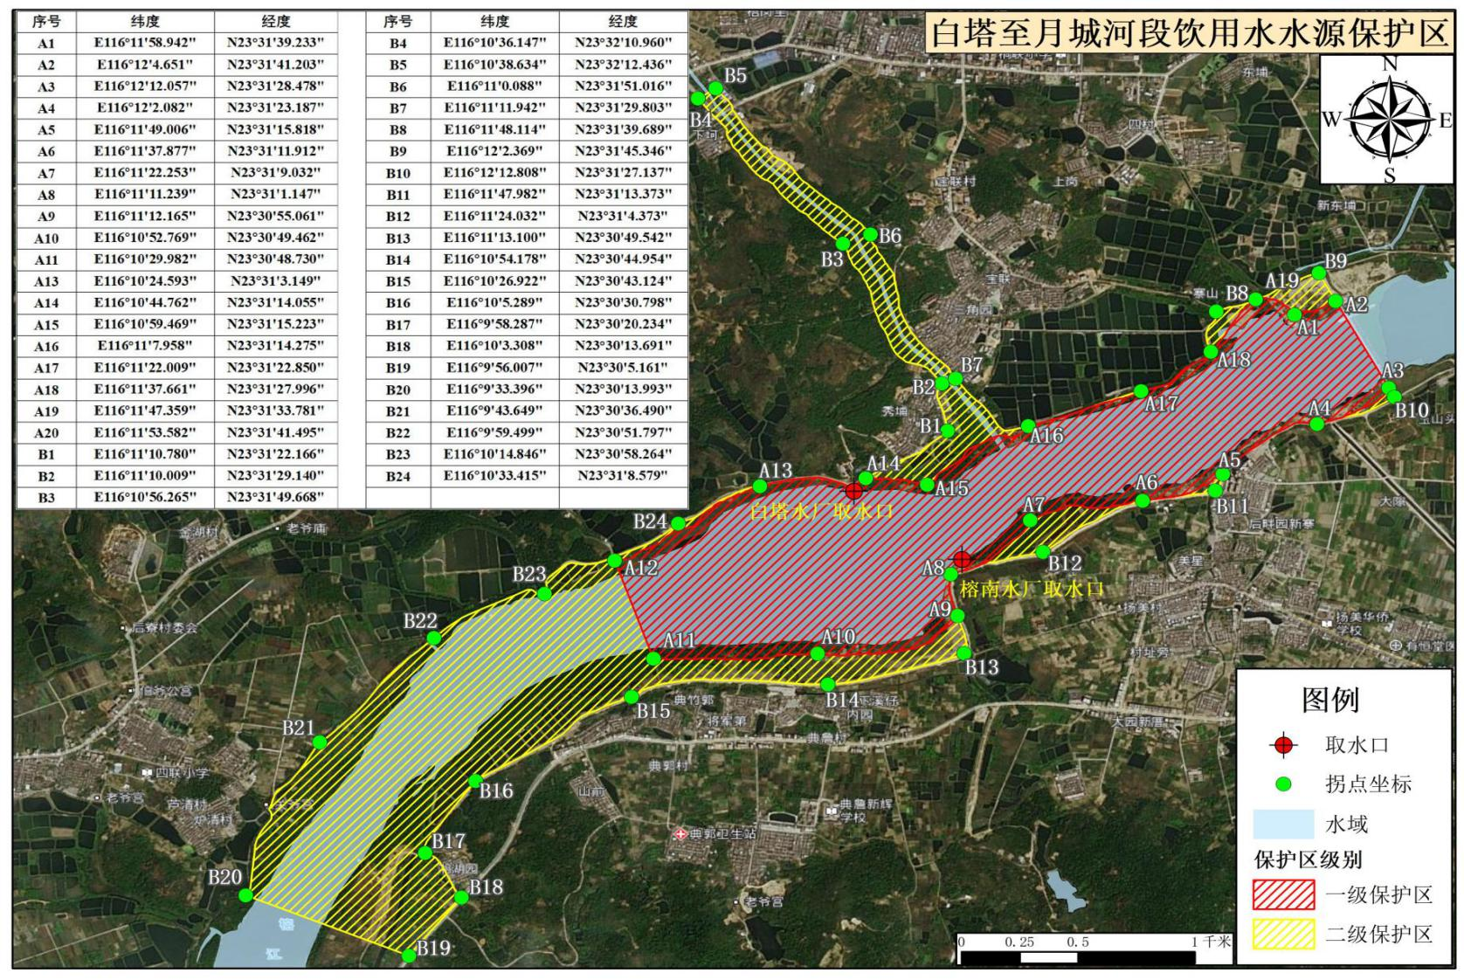

**图1 白塔至月城河段饮用水水源保护区范围**

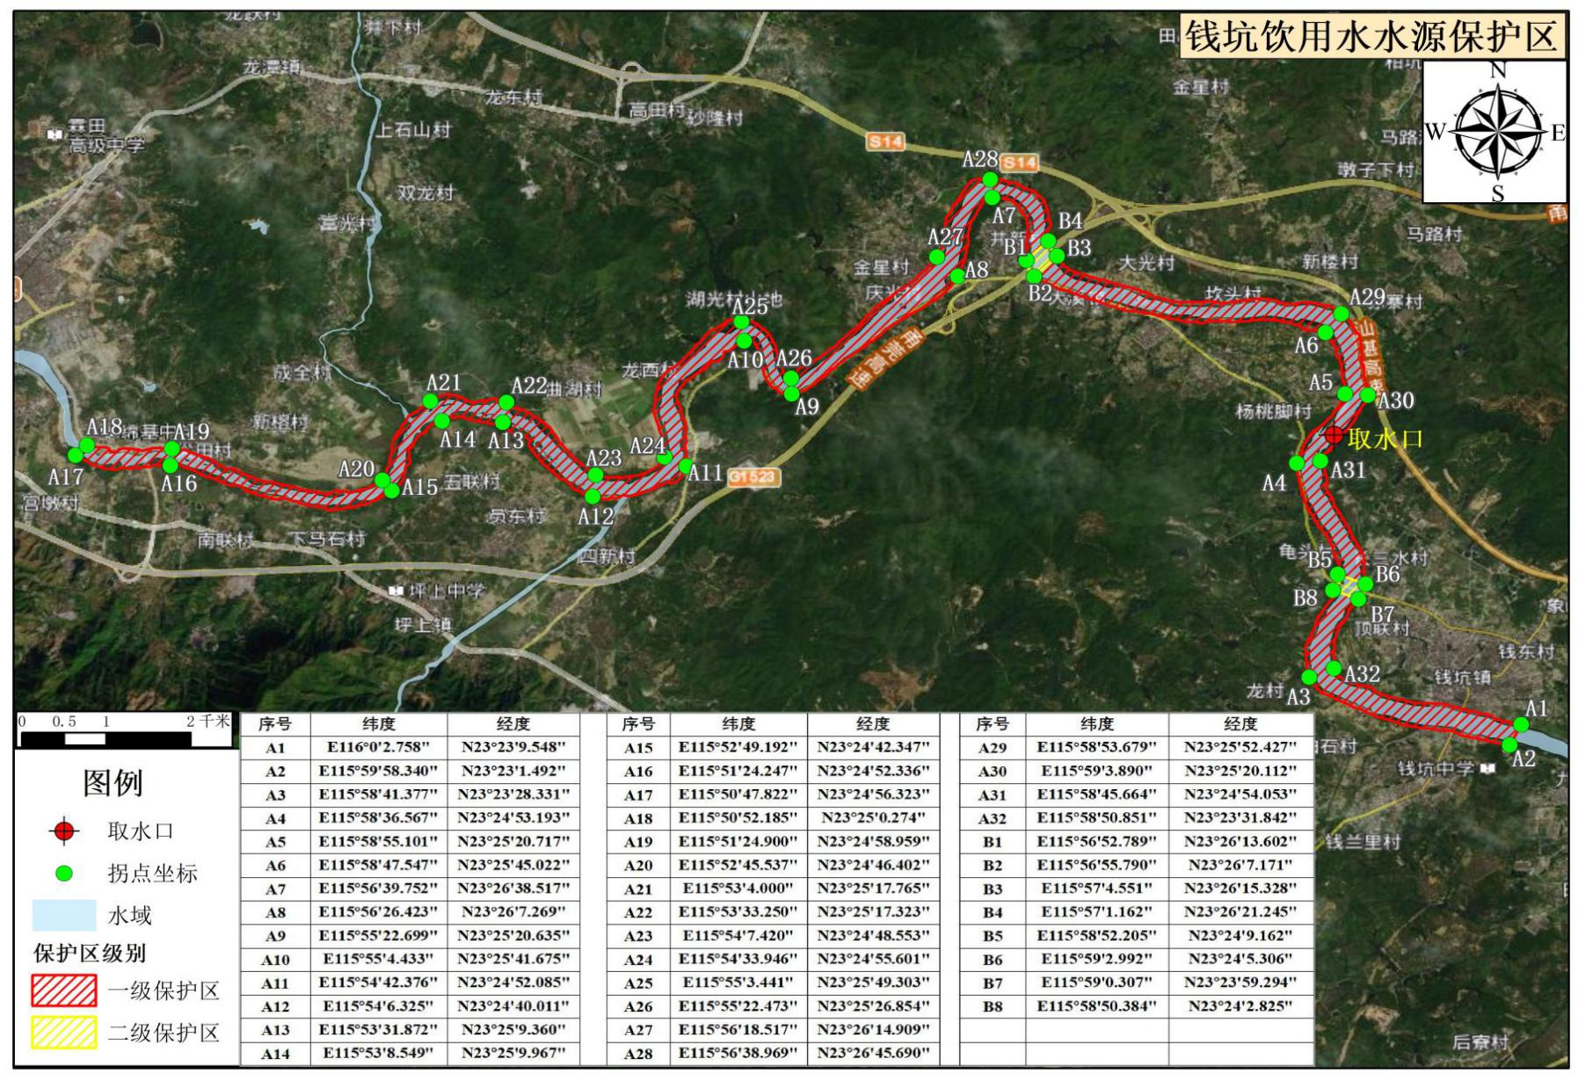

**图2 钱坑饮用水水源保护区范围**

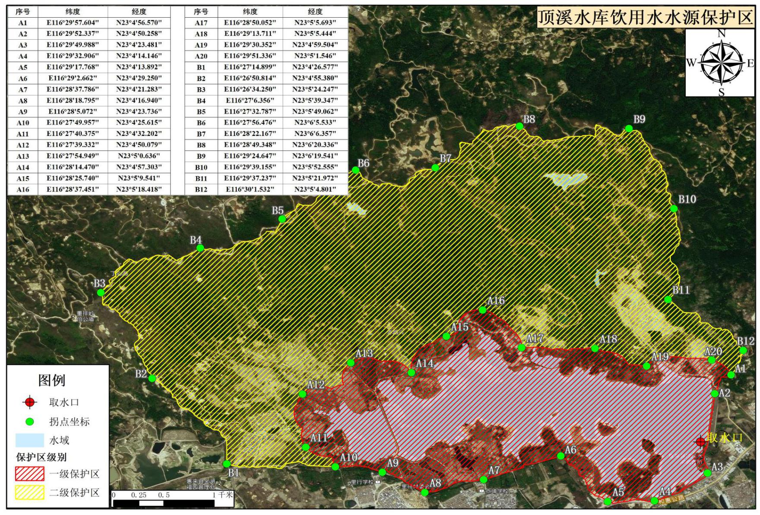

**图3 顶溪水库饮用水水源保护区范围**

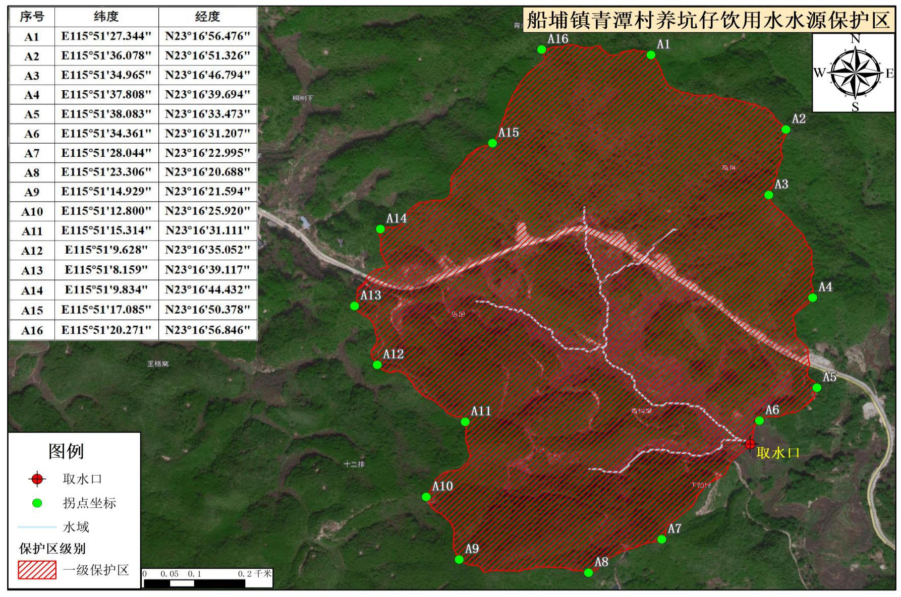

**图4 船埔镇青潭村养坑仔山溪水饮用水水源保护区范围图件**